CREATE AND CONFIGURE IBM CLOUD SERVICES

Creating IBM Watson IOT Platform and a Device

|  |  |
| --- | --- |
| Team ID | PNT2022TMID02 |
| Project Name | Smart Farmer - IoT Enabled Smart Farming Application |
| Team Members Name | Kamesh Kumar K ,Kaviyaraj C ,Javeed Akram Z , Kavinsaran JK |

Step:1 Log in to IBM Cloud Using Registered Id

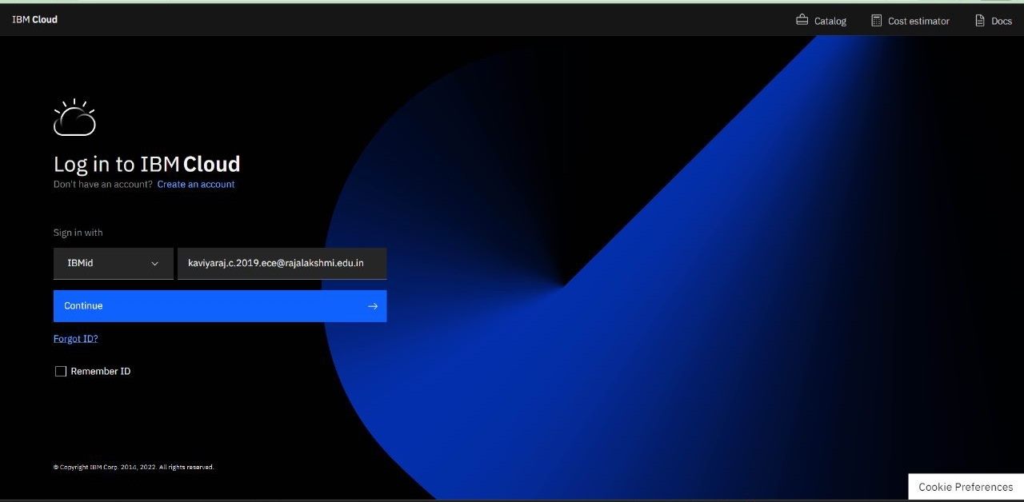

Step:2 Click on Catalog.

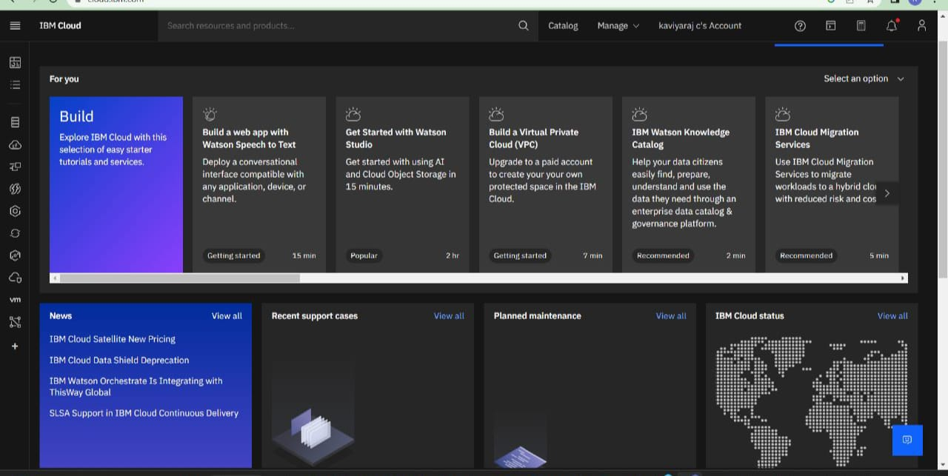

Step:3 Search For Internet of Things in catalog.

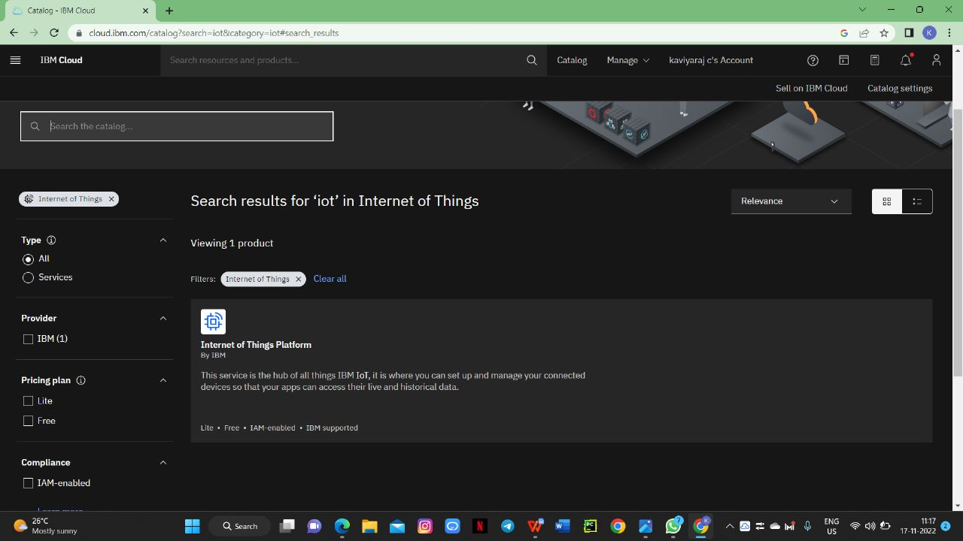

Step:4 Choose the Location As London, Select Free Plan and Click Create Button

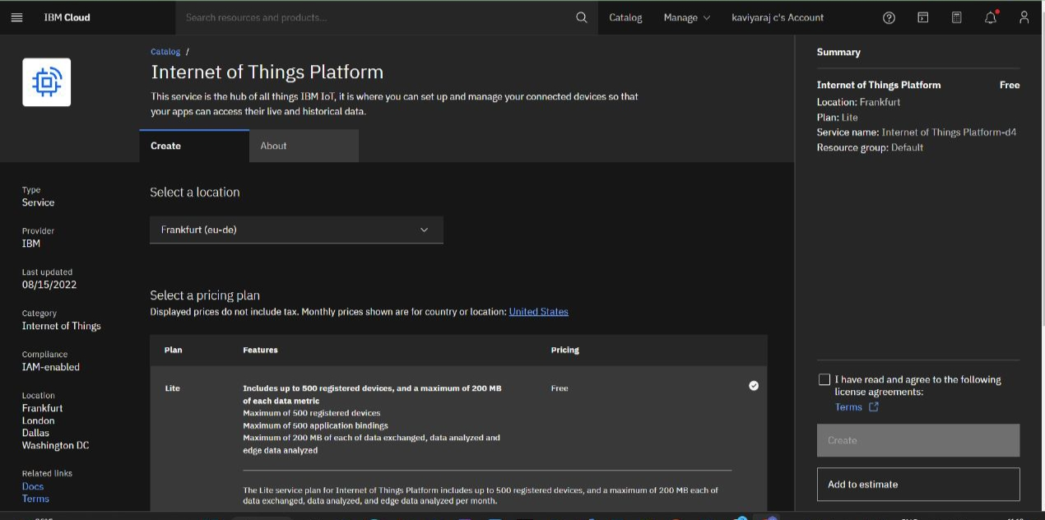

Step:5 Click on Launch Button Then Your IBM Watson IoT Platform Will be Opened

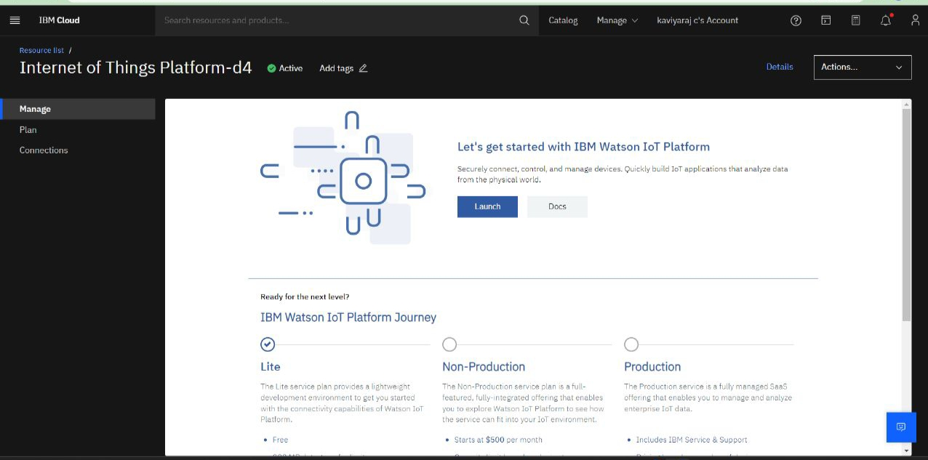

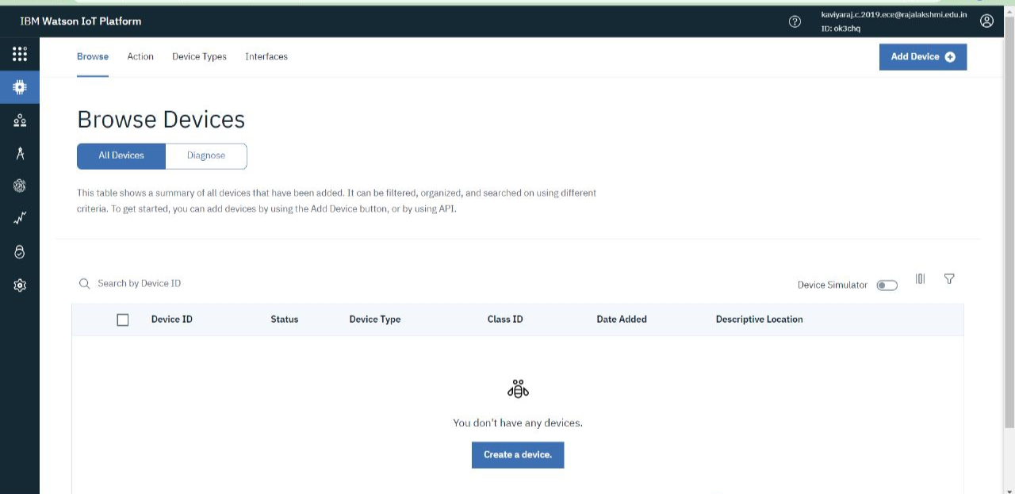

.

In This you Will be Able to Add Device and Create

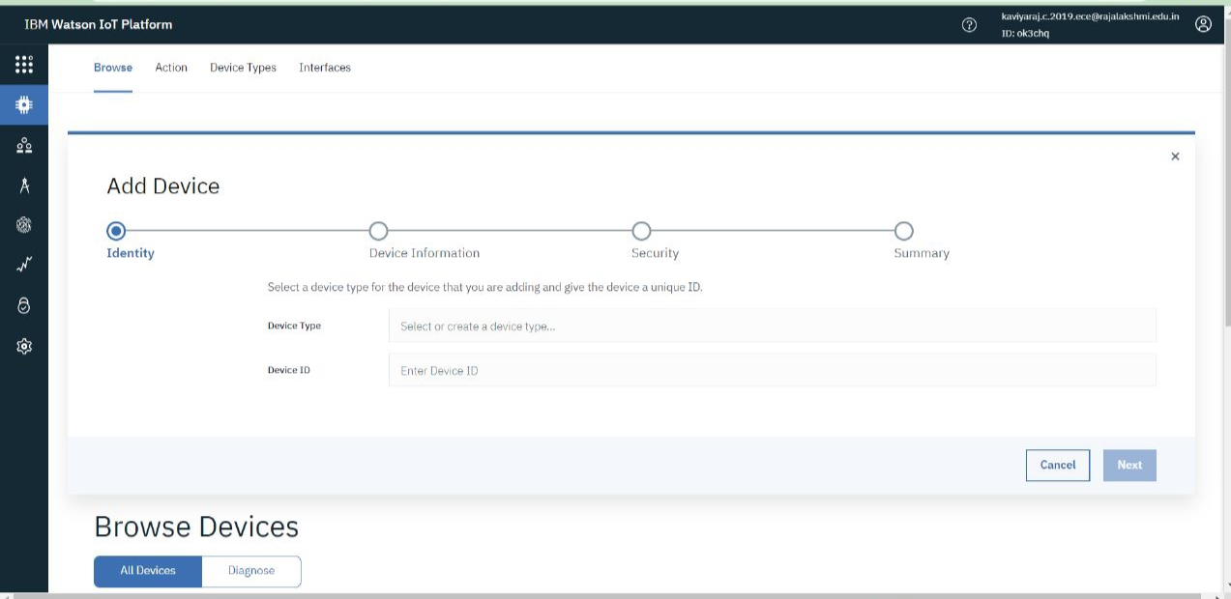

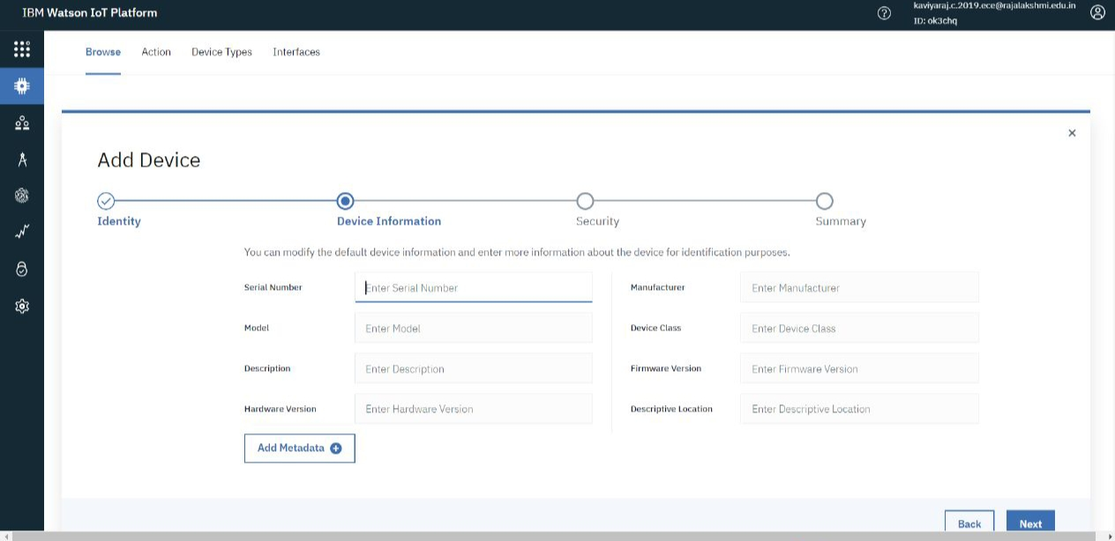

Step:6 Enter your Authentication Token Number

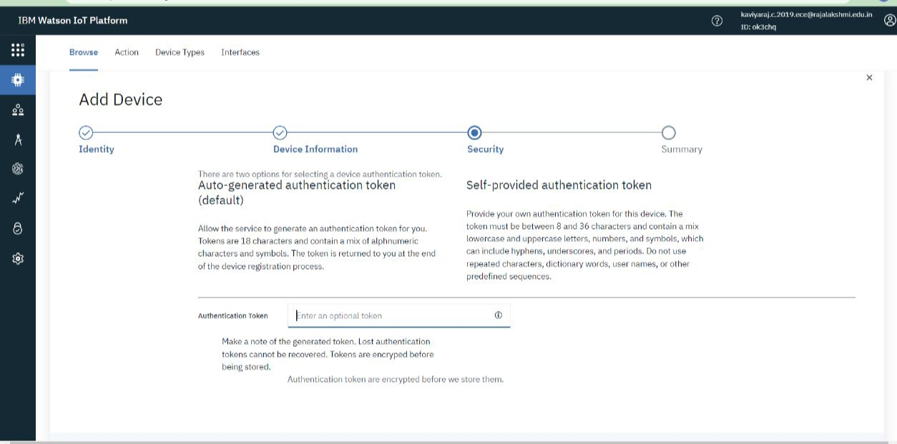

Step:7 click on Next & Finish Button Ur Device Will Be Added.

